NHANES Hypertension EDA Results

7/28/2021

Florida Polytechnic University

Ethan Bard

**Hypertensive Drug Prevalence by Cycle, Non-Hispanic Black**

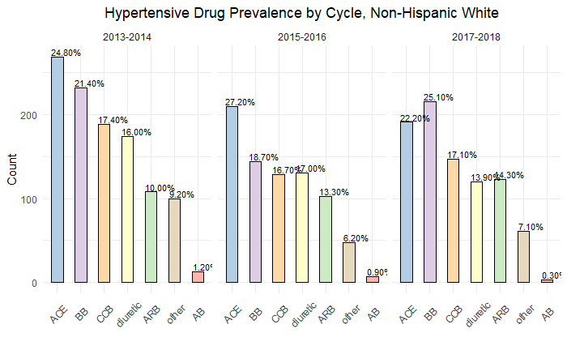

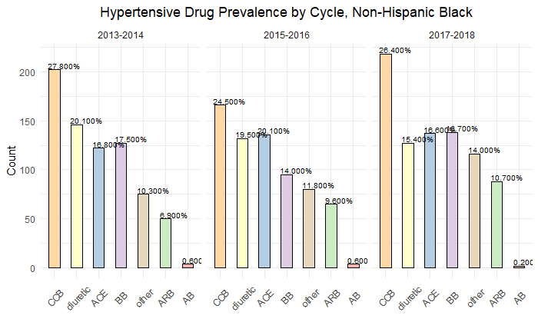

|  |  |  |  |  |  |
| --- | --- | --- | --- | --- | --- |
| **Hypertensive Drug Prevalence by Cycle, Non-Hispanic White** | | | | | |
|  | **2013-2014** | **2015-2016** | **% Change** | **2017-2018** | **% Change** |
| **ACE** | 24.80% | 27.2% | 2.4% | 22.2% | -5.0% |
| **BB** | 21.4% | 18.7% | -2.7% | 25.1% | 6.4% |
| **CCB** | 17.4% | 16.7% | -0.7% | 17.1% | 0.4% |
| **diuretic** | 16.0% | 17.0% | 1.0% | 13.9% | -3.1% |
| **ARB** | 10.0% | 13.3% | 3.3% | 14.3% | 1.0% |
| **other** | 9.2% | 6.2% | -3.0% | 7.1% | 0.9% |
| **AB** | 1.2% | 0.9% | -0.3% | 0.3% | -0.6% |

|  |  |  |  |  |  |
| --- | --- | --- | --- | --- | --- |
| **Hypertensive Drug Prevalence by Cycle, Non-Hispanic Black** | | | | | |
|  | **2013-2014** | **2015-2016** | **% Change** | **2017-2018** | **% Change** |
| **CCB** | 27.8% | 24.5% | -3.3% | 26.4% | 1.9% |
| **diuretic** | 20.1% | 19.5% | -0.6% | 15.4% | -4.1% |
| **BB** | 17.5% | 14.0% | -3.5% | 16.7% | 2.7% |
| **ACE** | 16.8% | 20.1% | 3.3% | 16.6% | -3.5% |
| **other** | 10.3% | 11.8% | 1.5% | 14.0% | 2.2% |
| **ARB** | 6.9% | 9.6% | 2.7% | 10.7% | 1.1% |
| **AB** | 0.6% | 0.6% | 0.0% | 0.2% | -0.4% |

| Hypertensive Drug Prevalence by Cycle, Non-Hispanic White | | | | |
| --- | --- | --- | --- | --- |
| Cycle | Drug Category | Freq | n | perc |
| 2013-2014 | ACE | 269 | 1085 | 24.80% |
| 2013-2014 | BB | 232 | 1085 | 21.40% |
| 2013-2014 | CCB | 189 | 1085 | 17.40% |
| 2013-2014 | diuretic | 174 | 1085 | 16.00% |
| 2013-2014 | ARB | 108 | 1085 | 10.00% |
| 2013-2014 | other | 100 | 1085 | 9.20% |
| 2013-2014 | AB | 13 | 1085 | 1.20% |
| 2015-2016 | ACE | 210 | 772 | 27.20% |
| 2015-2016 | BB | 144 | 772 | 18.70% |
| 2015-2016 | diuretic | 131 | 772 | 17.00% |
| 2015-2016 | CCB | 129 | 772 | 16.70% |
| 2015-2016 | ARB | 103 | 772 | 13.30% |
| 2015-2016 | other | 48 | 772 | 6.20% |
| 2015-2016 | AB | 7 | 772 | 0.90% |
| 2017-2018 | BB | 216 | 861 | 25.10% |
| 2017-2018 | ACE | 191 | 861 | 22.20% |
| 2017-2018 | CCB | 147 | 861 | 17.10% |
| 2017-2018 | ARB | 123 | 861 | 14.30% |
| 2017-2018 | diuretic | 120 | 861 | 13.90% |
| 2017-2018 | other | 61 | 861 | 7.10% |
| 2017-2018 | AB | 3 | 861 | 0.30% |

| Hypertensive Drug Prevalence by Cycle, Non-Hispanic Black | | | | |
| --- | --- | --- | --- | --- |
| Cycle | Drug Category | Freq | n | perc |
| 2013-2014 | CCB | 202 | 726 | 27.800% |
| 2013-2014 | diuretic | 146 | 726 | 20.100% |
| 2013-2014 | BB | 127 | 726 | 17.500% |
| 2013-2014 | ACE | 122 | 726 | 16.800% |
| 2013-2014 | other | 75 | 726 | 10.300% |
| 2013-2014 | ARB | 50 | 726 | 6.900% |
| 2013-2014 | AB | 4 | 726 | 0.600% |
| 2015-2016 | CCB | 166 | 678 | 24.500% |
| 2015-2016 | ACE | 136 | 678 | 20.100% |
| 2015-2016 | diuretic | 132 | 678 | 19.500% |
| 2015-2016 | BB | 95 | 678 | 14.000% |
| 2015-2016 | other | 80 | 678 | 11.800% |
| 2015-2016 | ARB | 65 | 678 | 9.600% |
| 2015-2016 | AB | 4 | 678 | 0.600% |
| 2017-2018 | CCB | 218 | 826 | 26.400% |
| 2017-2018 | BB | 138 | 826 | 16.700% |
| 2017-2018 | ACE | 137 | 826 | 16.600% |
| 2017-2018 | diuretic | 127 | 826 | 15.400% |
| 2017-2018 | other | 116 | 826 | 14.000% |
| 2017-2018 | ARB | 88 | 826 | 10.700% |
| 2017-2018 | AB | 2 | 826 | 0.200% |